PJ- Titan- Secure Cold Chain
Azure IOT Platform Requirements
High Level Design

Table of Contents
1. Introduction 4
2. Purpose/Audience 4
3. Goals and Objectives 4
4. System Architecture 5
4.1 Data flow between Azure platform sub-system 5
4.2 Platform Overview 6
5. Module Decomposition 6
5.1 Device Registration and Onboarding 7
5.2 Shipment Association Module 8
5.3 Data Streaming and Data Store Module 9
5.4 User Authentication and Role mapping 10
5.5 Heart beat monitoring and device connectivity status updates. 11
5.6 Shipment, Alert, Status Tracker 12
5.7 Api for external system (To be finalized based on specific customer requirements). 12
6. High Level Data Structure 13
7. HA and DR (High Availability and Disaster Recovery) 17

Introduction
Cold Chain management solution for Pharma addresses the challenges and concerns of the pharmaceutical companies, by providing near real-time tracking of the temperature sensitive consignments in a transparent and immutable manner throughout the supply chain The aim of this document is to describe software architecture, high level design overview, azure platform architecture, azure component relationship, data flow, high level data structure and external interface.

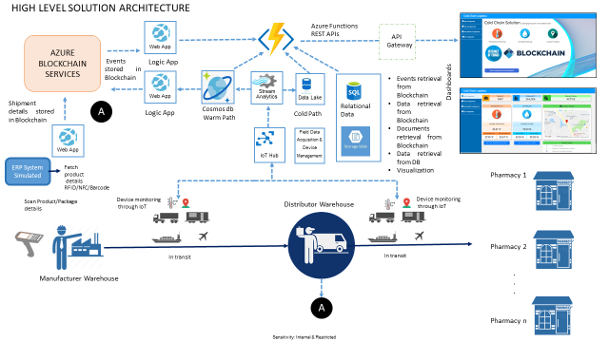

Figure 1 High level solution diagram

The diagram above shows the high level solution overview. The telemetry messages from sensors are fed to Azure platform through IOT Hub. The data is filtered and bifurcated using stream analytics rules and other functions logics and stored in different storages. The UI subsystem access the data store for visualization and dash board presentation.

Purpose/Audience
The audience for this document is the development team for the project and the product manager. It provides the guidance to the developers on construction of code and storage mechanism for related data. The product manager can verify the design to see if all of the functionality is covered as part of the project

Goals and Objectives
One of the challenges within cold chain system is to maintain the temperature range (2°C - 8°C) of the consignment throughout the delivery cycle, which is the most common range for the pharmaceutical industry. Multiple variables can affect the length of time a product’s temperature is considered controlled, including package size and thickness and the type and quantity of cooling agents used. The objective of the system should be monitoring these conditions in near real time in a secure, transparent and immutable manner and trigger alerts if there are temperature/humidity abnormalities.

System Architecture
This section details out the high level system architecture, sub system and system interactions

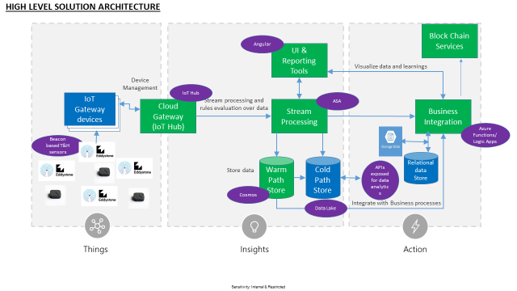

Figure 2 High level System Architecture

4.1 Data flow between Azure platform sub-system

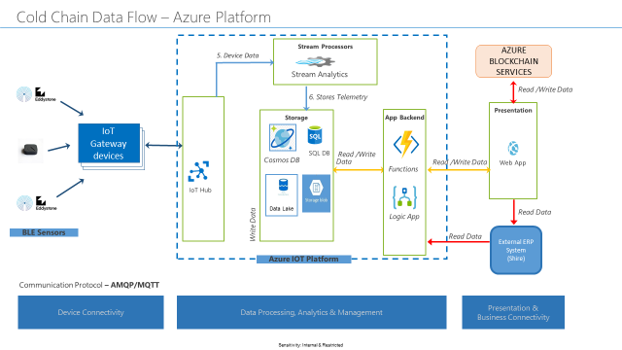
Figure 3 High level Data Flow

4.2 Platform Overview
The solution utilizes all the relevant services provided by Microsoft Azure
- Azure IoT Hub: Provides secure data transmission, collection framework and device management capabilities for temperature, humidity and location data captured from the sensors in a gateway.
- Azure Stream Analytics: Delivers inline analytics capabilities for data received in Azure IoT Hub.
- Azure Cosmos DB: Takes data from the stream analytics engine for hot path storage. The hot path storage helps quickly retrieve data for the purposes of visualizing important events and alerts.
- Azure Data Lake: Takes data from the stream analytics engine for cold path storage.
- Azure Functions: Fetches data from Azure Cosmos DB and aggregates it and exposes REST APIs for consumption by visualization components. Also exposes the APIs to external entities to fetch data from cold path storage (Azure SQL/Azure Datalake) for further analytics
- Azure Blob Storage: For storage and retrieval of shipment documents
- Azure Web services: Hosts the visualization components (dashboards).
- Azure SQL: For storing relational and sensor association information
- Blockchain services on Azure: Brings in immutability and transparency of transactions, events and alerts generated by the IoT sensors. This includes capturing the shipment details at origin, updating the shipment details at handoff points and updating the shipment details with events and alerts generated by the IoT solution.

High Level Data Structure

List of SQL DB tables

1.
Device Information Table
Name of the field | Element | Description
Id | Identity column | Primary Key
Mac Id/Device Id | Varchar 100 | Device Id/Mac id of Alphanumeric
Device Type | Varchar 100 | Alpha numeric
Active | Bool | True or False
Status | Varchar 100 | Connection status like offline,online,etc..
Created by | User Id
Created Time | Timestamp
Updated By | User Id
Updated Time | Timestamp

2.
Beacon Object Mapping Table
Name of the field | Element | Description
Beacon_Obj_Id | Identity column | Primary Key
Beacon Id | Varchar 100 | Alpha numeric
Object Id | Varchar 100 | Alpha numeric
Object Type | Varchar 100
TemperatureUpperLimit | Decimal
TemperatureLowerLimit | Decimal
HumidityUpperLimit | Decimal
HumidityLowerLimit | Decimal
Created by | User Id
Created Time | Timestamp
Updated By | User Id
Updated Time | Timestamp

3.
Shipping Master Table
Name of the field | Element | Description
ShipmasterId | Identity column | Primary Key
Shipment ID | Varchar 100 | From IDoc
Temperature Breach | int
Tamper Breach | int
Humidity Breach | int
Vibration Breach | int
Unreachable Device | int | True or False
Status | Varchar 100
Created by | User Id
Created Time | Timestamp
Updated By | User Id
Updated Time | Timestamp

5.
Shipment Meta Table
Name of the field | Element | Description
MetaId | Identity column | Primary Key
ShipmasterId | Identity column | From Shipmaster
Shipment ID | Varchar 100 | Idoc No
Source Loc | Varchar 100 | OSP
Destination Loc | Varchar 100 | WE
Logistic Partner | Varchar 100 | SP - Forwarding Agent
Date of Shipment | Date | EDT13 Goods Issue Activity Time
Delievery Date | Date
Invoice Document Ref | Varchar 100
PO Number | Varchar 100 | EDL41 purchase order number

6.
Shipment Product Table
Name of the field | Element | Description
Id | Identity column | Primary Key
ShipmasterId | Int | From Shipmaster
Shipment ID | Varchar 100 | Idoc No
Product Id | Varchar 100
Product | Varchar 100
Qty | int

7.
Shipping Association Table
Name of the field | Element | Description
ShipBoxAssociateId | Identity column | Primary Key
ShipmasterId | Varchar 100 | Shipmaster ID from Shipping Master table
Object_Beac_Id | Varchar 100 | From BeaconObjectmapping table
ObjectType | Varchar 100
AssociatedId | Varchar 100 | From BeaconObjectmapping table
AssociatedType | Varchar 100
Status | Varchar 100
Created by | User Id
Created Time | Timestamp
Updated By | User Id
Updated Time | Timestamp

8.
User Role Mapping Table
Name of the field | Element | Description
Id | Identity column | Primary Key
Username | Varchar 100
Email | Varchar 100
Role | Varchar 100
Status | Varchar 100
Created by | User Id
Created Time | Timestamp
Updated By | User Id
Updated Time | Timestamp

9.
Raw Alert Table
Name of the field | Element | Description
Id | Identity column | Primary Key
Gateway Id | Varchar 100
Beacon Id | Varchar 100
Global Alert | Bool
Temperature | Float
Humidity | Float
Vibration Alert | Bool
Tamper Alert | Bool
Temperature Alert | Bool
Humidity Alert | Bool
Location Lat | Float
Location Longitude | Float
Status | Varchar 100
Timestamp | Timestamp

10.
Alert Process Table
Name of the field | Element | Description
Id | Identity column | Primary Key
Shipment Id
Gateway Id | Varchar 100
Beacon Id | Varchar 100
Temperature | Float
Humidity | Float
Alert Type | Varchar 100
Location Latitude | Float
Location Longitude | Float
Acknowledge | Bool
Ack notes | Varchar 100
User | UserId
Status | Varchar 100
Timestamp | Timestamp

11.
Pallet Gateway Association Table
Name of the field | Element | Description
Id | Identity column | Primary Key
ShipmasterId | Int | From Shipmaster Table
Gateway_Mac_ Id | Int | From Device Table
Pallet Id | Int | From Beacon_Object Table
Tracker Id | Int | From Device Table
Created by | User Id
Created Time | Timestamp
Updated By | User Id
Updated Time | Timestamp

HA and DR (High Availability and Disaster Recovery)

7.1 IOT Hub

The solution leverages the HA and DR facilities provided by Azure itself.
The HA and DR features offered specifically by the IoT Hub service are Intra-region HA and
cross region DR.
The IoT Hub service provides intra-region HA by implementing redundancies in almost all layers of the service. The SLA published by the IoT Hub service is achieved by making use of these redundancies. No additional work is required by the developers of an IoT solution to take advantage of these HA features.
There are two DR options available in case of extended outages. They are "Microsoft initiated failover" and "manual failover". The fundamental difference between the two is that Microsoft initiates the former and the user initiates the latter.

7.2 Stream Analytics

Currently Azure Stream Analytics does not provide automatic geo-failover but you can achieve geo-redundancy by deploying identical ASA jobs in multiple Azure regions. Diagnostic and troubleshooting shall be done by analysing logs, web hooks, Azure Monitor and Azure Resource Health utilities.

7.3 Data store (Cosmos/SQL DB)

The solution leverages the HA and DR facilities like automatic backup and restore and
global distribution of data in multi regions provided by Azure itself.
The data is replicated by configuring different regions (Geo Redundant Storage) and enabling automatic failover.
Back up will be taken at regular intervals and stored in azure storage containers. For Standard, and Premium SQL Database tiers, point-in-time restore can be taken to recover database.

